

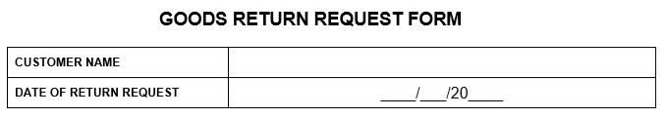

**Customer to complete Columns A to E -Powerdek Rep to complete Columns F**

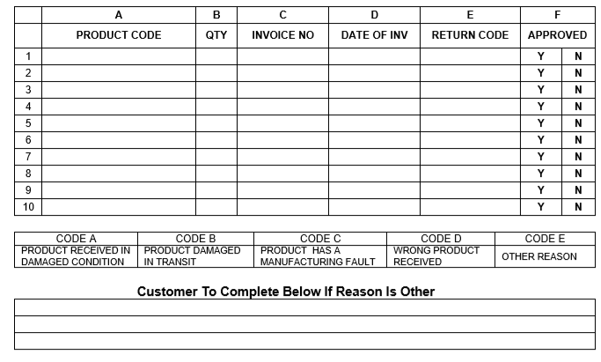

|  |  |  |  |
| --- | --- | --- | --- |
|  |  |  |  |
| **Customer Signature** | **Return Date** | **Powerdek Service Signature** | **Inspection Date** |

**To be completed by Powerdek Warehouse staff**



**PLEASE EMAIL TO – SERVICE.PTA@POWERDEK.CO.ZA**